Craft- Solomon Builds the Temple
For this craft, talk to your child about how God is with us everywhere and how we can worship Him at church, at home, in the car, anywhere! End in prayer asking God to help us know right from wrong and to love Him with all our heart!
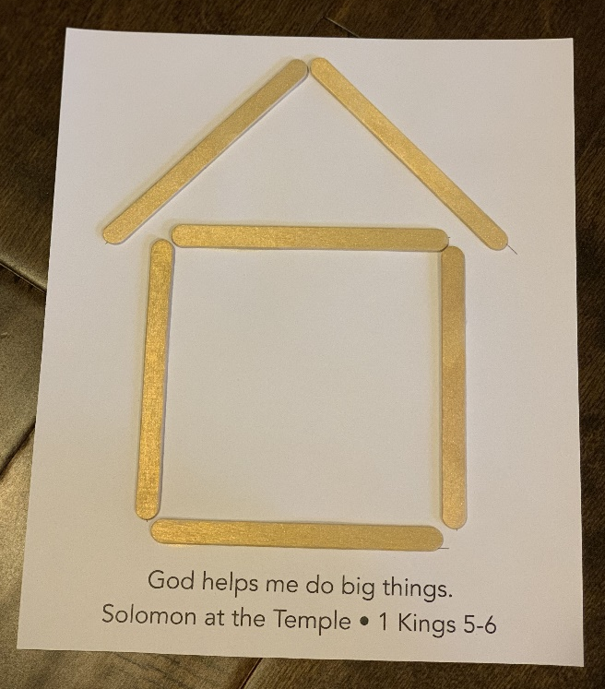
You Will Need:
-Craft sheet
-Popsicle sticks
-Glue

God helps me do big things.
Solomon at the Temple. 1 Kings 5-6

