Saul Begins to Follow Jesus Craft

For this craft, talk about how Saul's heart was changed by Jesus. Talk about how Saul became a kind and told everyone about Jesus. End in prayer.

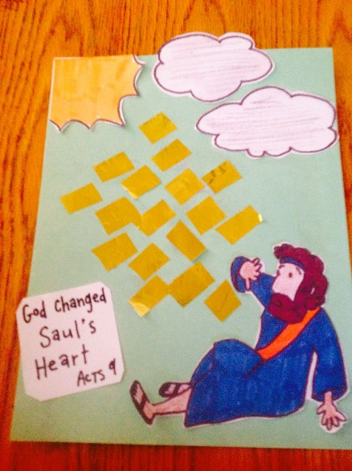You Will Need:

-crayons

-yellow tissue paper or construction paper

-glue

-scissors

Help your child glue yellow tissue paper pieces to their craft. See picture for sample. May also use cotton balls for clouds. Next, have your child color the sun. End in prayer thanking Jesus for forgiving us when we do wrong and changing our heart.



Jesus Changed Saul’s Heart.

Acts 9