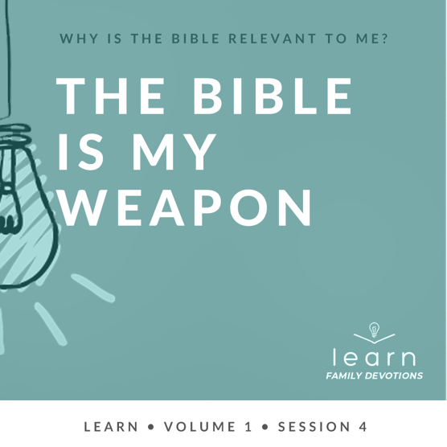

Day 1
Faith Fact
I will use God’s Word.

Faith Verse
2 Timothy 3:16 (NLT)
All Scripture is inspired by God and is useful to teach us what is true.

Question of the Day: Why is it so important for me to use God’s Word?
Read about It
Read: Ephesians 6:11, 17
Imagine trying to play basketball without a ball or a basketball hoop. Imagine trying to hammer a nail without a hammer. Imagine trying to go skydiving without a parachute. Proper equipment is necessary to be able to do each task efficiently and safely.
This is similar to how it works with God’s Word. The devil constantly attacks us, trying to turn us away from God. The devil wants to mess up our life, turn us from God and keep us from experiencing all God has for us. The Bible says that we should put on the full armor of God so we can stand against the devil’s schemes. The most powerful weapon we have to fight the devil is the sword of the Spirit, which is the Word of God. When we fill our heart with God’s Word, we can use that as a weapon to fight the enemy’s attacks.
Talk about It
Question 1. Why should we put on the full armor of God?
Answer 1. So we can stand firm against all strategies of the devil (Ephesians 6:11)

Question 2. What is the sword of the Spirit?
Answer 2. The Word of God (Ephesians 6:17)

Question 3. How does it make you feel to know God has given you a weapon, His Word, to fight the devil with?
Answer 3. Answers will vary.

Question 4. How can you use the truths of God’s Word to fight the devil?
Answer 4. Answers will vary.

Question 5. In what part of your life do you need to be sure you’re using this special weapon to fight the devil with?
Answer 5. Answers will vary.
Pray about It
God, thank You for giving us everything we need to live a godly life. Thank You for Your Word that speaks truth and fights off the attacks of the enemy. Help us to make sure that we are putting on our armor every day and that we are always ready to use Your Word. We love You. Amen.

Day 2
Faith Fact
I will use God’s Word.

Faith Verse
2 Timothy 3:16 (NLT)
All Scripture is inspired by God and is useful to teach us what is true.

Question of the Day: When should I use God’s Word?
Read about It
Read: 2 Timothy 4:2–4
A service dog is specially trained to help people who have disabilities. A guide dog can help someone who is blind or visually impaired know when it’s safe to cross a street. A seizure dog can detect if the person it helps is having a seizure. Seizures can be very dangerous. The dogs able to do these tasks because they’ve been trained to know what to do. These dogs are always ready, no matter what, to put that training into action.
The Bible tells us it’s important to be prepared to use God’s Word. No matter what time of day, no matter how we’re feeling, and no matter what’s going on, we need to be ready and willing to use God’s Word. This is why it’s important to know His Word and have it hidden in our heart. Then, when we need it, we can use it to live for Jesus.
Talk about It
Question 1. When should we use God’s Word?
Answer 1. We should be prepared to use it at any time. (2 Timothy 4:2)
Question 2. What is God’s Word used for?
Answer 2. God’s Word can be used to correct, rebuke, and encourage others. (2 Timothy 4:2)

Question 3. Why should we always be prepared to use God’s Word?
Answer 3. So we can live according to God’s truth no matter the situation. Answers may vary.
Question 4. What can happen when we no longer listen to or use God’s Word?
Answer 4. We can become people who follow our own desires, reject the truth, and chase after things that are not of God. (2 Timothy 4:3–4)
Question 5. How can you be ready to use God’s Word in a situation that you are facing right now?
Answer 5. Answers may vary.
Pray about It
God, help us to fill our hearts with Your Word. Help us to allow Your Word to teach us how to live so we can be ready to do whatever You want us to do and live for You. Amen.

Day 3
Faith Fact
I will use God’s Word.

Faith Verse
2 Timothy 3:16 (NLT)
All Scripture is inspired by God and is useful to teach us what is true.

Question of the Day: How does using God’s Word help me live a godly life?
Read about It
Read: Hebrews 4:12
One of the most important skills of a top chef is to be able to use a knife properly. Great chefs doesn’t just go chopping away at a piece of meat to prepare it for cooking. Instead, they use a very sharp knife to cut away the pieces of meat that are not needed. They are careful not to ruin the good parts of the meat. Chefs must know precisely where to cut to get the results they want. A sharp knife in the hands of a master chef is a powerful tool that produces some amazing food!
Like a chef’s knife, God’s Word is very sharp. It is also alive and powerful. This means that the Holy Spirit can speak to us through God’s Word and change us. God’s Word is a powerful tool to help us get rid of the bad things in our life and to help us grow in the good things that God desires for us. Because God’s Word is true and perfect, it can help expose the parts of us that don’t align with God’s Word. It also can help us fight temptation, selfishness, and lies from the enemy. When we use God’s Word as a weapon to fight the bad things in our heart, God will help us get rid of those things so we can live a godly life.
Talk about It
Question 1. How is the Bible different from any other book?
Answer 1. The Word of God is alive and powerful. (Hebrews 4:12)

Question 2. What does God’s Word help expose in us?
Answer 2. Our innermost thoughts and desires (Hebrews 4:12)

Question 3. How can God’s Word help us fight the bad things that we sometimes allow in our life?
Answer 3. By showing us the truth and helping us know what things we need to get rid of. Answers may vary.

Question 4. What parts of your life do you need to use God’s Word in to make you more like Him?
Answer 4. Answers will vary.

Question 5. How can you use the Word of God to help you grow in the things He wants you to have?
Answer 5. Answers will vary.
Pray about It
God, thank You for Your Word that is alive and powerful. Help me to allow Your Word to expose the deepest parts of my heart and life and use it to make me more like Jesus. I love You. Amen.

Day 4
Faith Fact
I will use God’s Word.

Faith Verse
2 Timothy 3:16 (NLT)
All Scripture is inspired by God and is useful to teach us what is true.

Question of the Day: How can I use God’s Word to help others?
Read about It
Read: Acts 18:24–28
The Bible calls Apollos an “eloquent speaker.” That means that he was educated and able to speak to others well. He had studied the Scriptures, and he knew them well. Apollos traveled around telling others about Jesus. But sometimes, he came across people who would argue with him about the truth. Have you ever had someone argue with you about what the truth is? It can be frustrating when you know the truth, but they don’t understand. Because Apollos had studied and learned the Scriptures so well, he was able to use the truth from God’s Word to help people understand who Jesus is.
God’s Word is powerful because it is given to us directly from God and it teaches us what is true. When we take the time to study and learn it, we can know how to apply it to our own life. Also, we can share it with others to help them know the truth for themselves.
Talk about It
Question 1. What did Apollos use to prove who Jesus was?
Answer 1. The Scriptures (Acts 18:28)

Question 2. Did Apollos stop learning and growing in God’s Word when he knew a lot of it?
Answer 2. No, Priscilla and Aquila helped him understand more about God, and he continued to learn. (Acts 18:26)

Question 3. How can you learn more about God’s Word for yourself?
Answer 3. By spending time reading it, memorizing it, and studying it. Answers may vary.
Question 4. When could you use God’s Word to help someone understand who Jesus is?
Answer 4. Answers will vary.

Question 5. Who in your life needs to know the truths that are in God’s Word?
Answer 5. Answers will vary.
Pray about It
God, I want to be a student of Your Word, and I want to know the truths that are found in it. Please give me wisdom to know how to use Your Word to share those truths with others. Amen.

.

