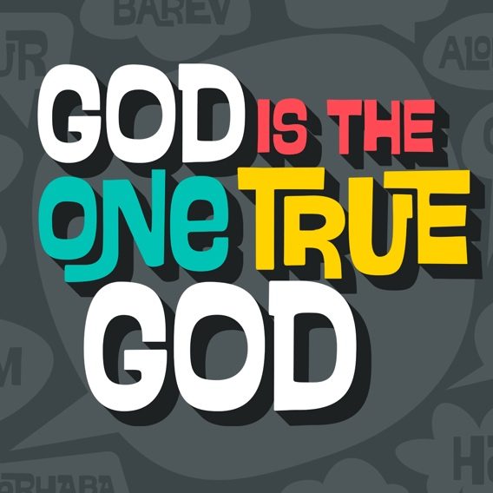

**Day 1**

|  |
| --- |
| **Faith Fact**  My God is the one true God.  **Faith Verse**  Isaiah 55:8 (NLT)  “My thoughts are nothing like your thoughts,” says the Lord. “And my ways are far beyond anything you could imagine.”  **Question of the Day: When have you felt God’s presence?** |

**Read about It**

**Read:** Daniel 3:14–18

Have you ever had such a bad sunburn that your skin blistered? What did that feel like? How is getting burned by the sun different from being burned by touching something that is hot? Shadrach, Meshach, and Abednego were willing to honor God with their lives even if that meant being burnt in a fiery furnace.

Even though they faced a terrible punishment, they stood up to the king and trusted God to help them. Shadrach, Meshach, and Abednego knew that God is the one true God. They knew God had the power to rescue them. This is an incredible reminder today that in our life, we can have faith, and trust God to be with us in all circumstances!

**Talk about It**

|  |
| --- |
| **Question 1.** How did King Nebuchadnezzar respond to reports that Shadrach, Meshach and Abednego had not obeyed his orders?  **Answer 1.** He questioned them and offered them another chance to obey. (Daniel 3:14–15) |
| **Question 2.** How do you think Shadrach, Meshach, and Abednego felt when the king confronted them?  **Answer 2.** Answers may vary. |
| **Question 3.** What did King Nebuchadnezzar say that might mean he thought he was more powerful than God?  **Answer 3.** “If you refuse, you will be thrown immediately into the blazing furnace. And then what god will be able to rescue you from my power?” (Daniel 3:15) |
| **Question 4.** What do you think about how Shadrach, Meshach, and Abednego responded to the king?  **Answer 4.** Answers will vary. |
| **Question 5.** When do you think Shadrach, Meshach and Abednego felt God’s presence?  **Answer 5.** Answers will vary. |

**Pray about It**

Dear God, thank You for showing us in the Bible that You are the one true God and that You are always with us. I may go through some hard experiences, but I can have faith and trust in who You are. God, as you were with Shadrach, Meshach, and Abednego, I know that You are with me. I praise You, God, and thank You for who You are. Amen.

**Day 2**

|  |
| --- |
| **Faith Fact**  My God is the one true God.  **Faith Verse**  Isaiah 55:8 (NLT)  “My thoughts are nothing like your thoughts,” says the Lord. “And my ways are far beyond anything you could imagine.”  **Question of the Day: What can we learn about God from His creation?** |

**Read about It**

**Read**: Isaiah 45:18

What is something that you love a lot? It could be a person, place, or thing. Do you know who created that person, place or thing? The first chapter of the Bible, Genesis 1, talks about how God created our world. The Bible mentions God as Creator in other places too.

Isaiah 45:18 says God created the heavens and earth. Have you ever stopped and looked at the world God has created? It’s pretty amazing when you look at it. God created every single star, every grain of sand, every bird, every flower, and He even created you! He knows you by name and loves you. When you stop and look at creation, you can truly know that God is the one true God and there is no one else like Him!

**Talk about It**

|  |
| --- |
| **Question 1.** What is your favorite thing God created?  **Answer 1.** Answers will vary. |
| **Question 2.** How does creation show us that God is the one true God?  **Answer 2.** Answers may vary. |
| **Question 3.** Where do we find the story of creation?  **Answer 3.** Genesis 1 |
| **Question 4.** Why is the story of creation important?  **Answer 4.** Answers will vary. |
| **Question 5.** If God created the world, what does that say about His ability to help you?  **Answer 5.** Answers will vary. |

**Pray about It**

Dear God, thank You for showing us in creation that You are the one true God. There is no one like You, God, and we give You praise for You are amazing. I love You. Amen.

**Day 3**

|  |
| --- |
| **Faith Fact**  My God is the one true God.  **Faith Verse**  Isaiah 55:8 (NLT)  “My thoughts are nothing like your thoughts,” says the Lord. “And my ways are far beyond anything you could imagine.”  **Question of the Day: What does it mean to have other gods?** |

**Read about It**

Read: Exodus 20:3

The Ten Commandments are rules God gave people. We find them in Exodus 20 in the Old Testament. The first one says, “You must not have any other god but me.” We know that our God is the one true God.

We might not be tempted by false religions, but sometimes we may allow things to take the place of God in our life. The things we allow in our life can become a problem. If they take away from the time we spend with God, negatively change how we act, or we let them rule over us in a way only God should, they are a problem. The second commandment says, “You must not make for yourself an idol.” This means that we should not worship or give something a higher value or regard than God. It’s important that we put God first in our life and have a close relationship with him.

**Talk about It**

|  |
| --- |
| **Question 1.** Where in the Bible are the Ten Commandments found?  **Answer 1**. Exodus 20 |
| **Question 2.** What is the first commandment?  **Answer 2.** “You must not have any other god but me.” (Exodus 20:3) |
| **Question 3.** Why do you think God put this commandment first?  **Answer 3.** Answers will vary. |
| **Question 4.** Why is it important to keep our relationship with God as the most important one in our life?  **Answer 4.** Answers will vary. |
| **Question 5.** Is there anything you sometimes put before God?  **Answer 5.** Answers will vary. |

**Pray about It**

Dear God, thank You that You are the one true God! Thank You that You loved me so much that You sent Jesus to the world to die in my place and forgive my sins so that I can experience forgiveness and love. God, thank You for being who You are in my life, and I choose to put You first. Amen.

**Day 4**

|  |
| --- |
| **Faith Fact**  My God is the one true God.  **Faith Verse**  Isaiah 55:8 (NLT)  “My thoughts are nothing like your thoughts,” says the Lord. “And my ways are far beyond anything you could imagine.”  **Question of the Day: When has God helped you?** |

**Read about It**

**Read:** Hosea 13:1–6

In the verses we just read, we learned that some of God’s people sinned by worshipping a fake god. They turned from only worshipping the true God. They also started making silver idols and worshipping calf idols. God reminded the people about how He had been with them, had delivered them out of Egypt, and how He had protected them.

Have you seen God do something in your own life? As time goes by, you may forget what God has done. When God does something in your life, it is important to write it down in a journal or create a place where you can hold all those memories. Then, when you look back, you can see all the times God has helped you. Reflecting on what God has done will help you remember who God is!

**Talk about It**

|  |
| --- |
| **Question 1.** God brought the Jewish people out of what land?  **Answer 1.** Egypt (Hosea 13:4) |
| **Question 2.** Why were the people being reminded that God had brought them out of Egypt?  **Answer 2.** They had forgotten about Him. |
| **Question 3.** What is God asking the people to do?  **Answer 3.** Worship only Him. (Hosea 13:6) |
| **Question 4.** Why is it important for us to remember times that God has been with us in the past?  **Answer 4.** It helps us remember who God is. |
| **Question 5.** How can you make sure you put God first?  **Answer 5.** Answers will vary. |

**Pray about It**

Dear God, thank You for all the times that You have been faithful to me. I know You are the one true God and You are always with me. Show me if anything has tried to take your place in my life.