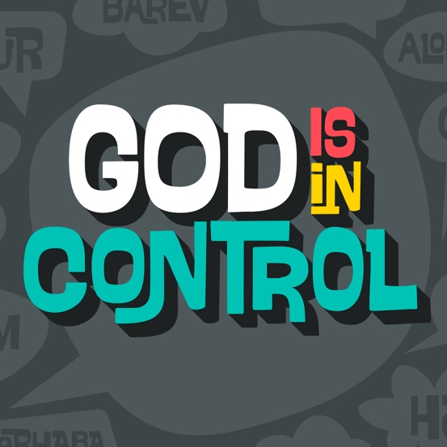

**Day 1**

|  |
| --- |
| **Faith Fact**  My God is in control.  **Faith Verse**  Isaiah 55:8 (NLT)  “My thoughts are nothing like your thoughts,” says the Lord. “And my ways are far beyond anything you can imagine.”  **Question of the Day: Who decides what you make with play dough?** |

**Read about It**

**Read:** Jeremiah 18:1–11

Have you ever created anything with play dough? It’s fascinating to watch people mold and shape play dough. The process begins with a lump, but may end with something incredible.

Today we are talking about God leading Jeremiah to a potter’s shop and speaking to him there. As Jeremiah watched the potter, the potter saw that his creation was flawed, so he started over.

In our life, sometimes things keep us from being what God wants us to be. Maybe it is the choices we make, the people we hang out with, or fear. When we don’t allow God to shape those areas in our life, we fail to meet what God wants for our life. Today, we are reminded that God is in control, and we can trust Him with every area in our life. We need to turn from the things that hold us back and follow God’s plan for us.

**Talk about It**

|  |
| --- |
| **Question 1.** In the verses we read, who did the Lord give a message to?  **Answer 1.** Jeremiah (Jeremiah 18:1) |
| **Question 2.** Where did God tell Jeremiah to go?  **Answer 2.** A potter’s shop (Jeremiah 18:2) |
| **Question 3.** What did the potter do to the jar that wasn’t turning out like he wanted?  **Answer 3.** He smashed it and started over (Jeremiah 18:4) |
| **Question 4.** What did God say about the nation of Israel?  **Answer 4.** Israel was in His hand just as the clay was in the potter’s hand. (Jeremiah 18:6) |
| **Question 5.** What might keep you from being everything God planned you to be?  **Answer 5.** Answers may vary. |

**Pray about It**

Dear God, thank You for molding and shaping me. I trust You, and I know You have an amazing plan for me. Lead me and direct my path. Help me be the person You want me to be. God, I give You every area of my life, and I trust You. Amen.

**Day 2**

|  |
| --- |
| **Faith Fact**  My God is in control.  **Faith Verse**  Isaiah 55:8 (NLT)  “My thoughts are nothing like your thoughts,” says the Lord. “And my ways are far beyond anything you can imagine.”  **Question of the Day: When should I be scared?** |

**Read about It**

**Read:** Psalm 118:6–7

When has someone been really mean to you? When have been you afraid? Fear can make us feel anxious.

When we feel afraid or anxious, we can find comfort in Psalm 118:6–7. These verses tell us God is for us, and He will help us. That means we don’t have to be afraid. When we learn to listen to God and to trust that He is in control, we can remember that God is with us, no matter what happens. And He can bring something good from any situation.

**Talk about It**

|  |
| --- |
| **Question 1.** According to Psalm 118:6, who is the Lord is for?  **Answer 1.** For me (Psalm 118:6) |
| **Question 2.** What do you think “The Lord is for me” means?  **Answer 2.** Answers may vary. |
| **Question 3.** How does knowing God is with you make you feel?  **Answer 3.** Answers may vary. |
| **Question 4.** When has God helped you?  **Answer 4.** Answers will vary. |
| **Question 5.** When you feel afraid, what can you do?  **Answer 5.** Pray, read the Bible, talk to another believer. Answers may vary. |

**Pray about It**

Dear God, thank You for being with me and helping me. God, help me to trust You to bring good from every situation. May I find hope and peace in who You are. Amen.

**Day 3**

|  |
| --- |
| **Faith Fact**  My God is in control.  **Faith Verse**  Isaiah 55:8 (NLT)  “My thoughts are nothing like your thoughts,” says the Lord. “And my ways are far beyond anything you can imagine.”  **Question of the Day: What does God want us to know?** |

**Read about It**

**Read:** Psalm 23

When we read Psalm 23, we find the Lord described as our “shepherd.” A shepherd takes care of his sheep. He knows all of them, and his goal is to keep them safe.

When you watch sheep, you can see the special bond they have with their shepherd. The sheep know the shepherd’s voice, and they know the shepherd will protect them, guide them, and meet their needs. The sheep know they can trust the shepherd.

That is what God desires from us. God wants us to know that we can trust Him to protect us, to guide us, and to meet our needs. He wants us to know that we are safe when we listen to and obey Him.

**Talk about It**

|  |
| --- |
| **Question 1.** In Psalm 23:1, it says that “The Lord is my shepherd.” What is the second part of that verse?  **Answer 1.** “I have all that I need.” (Psalm 23:1) |
| **Question 2.** Which part of these verses stands out to you the most?  **Answer 2.** Answers will vary. |
| **Question 3**. In Psalm 23:4, what do the shepherd’s rod and staff do?  **Answer 3.** Protect and comfort me (Psalm 23:4) |
| **Question 4.** How should Psalm 23 affect our life?  **Answer 4.** Answers will vary. |
| **Question 5.** What does it mean to “live in the house of the Lord forever”?  **Answer 5.** Answers may vary. |

**Pray about It**

Dear God, thank You for being my shepherd and for leading and guiding me. God, help me listen to Your voice and trust You. Thank You that You are giving me rest, guidance, protection, comfort, and strength. I love You. Amen.

**Day 4**

|  |
| --- |
| **Faith Fact**  My God is in control.  **Faith Verse**  Isaiah 55:8 (NLT)  “My thoughts are nothing like your thoughts,” says the Lord. “And my ways are far beyond anything you can imagine.”  **Question of the Day: Do you need to understand what’s happening?** |

**Read about It**

**Read:** Isaiah 55:8

Close your eyes and imagine that you are sitting at your kitchen table and it is covered with puzzle pieces. As you start putting the puzzle together, the image begins to emerge. Finally, you finish putting the puzzle together, and you can see the complete picture.

Life can be like that puzzle. Over time, God reveals your life to you piece by piece. Eventually, you see how the pieces connect and how beautiful the final result is.

It is important to trust God even when you don’t understand the things that are happening in your life. God can see, think, and work in ways you can’t understand. He can make any situation work with His plan for your life.

**Talk about It**

|  |
| --- |
| **Question 1.** When has God worked in your life?  **Answer 1.** Answers will vary. |
| **Question 2.** When have you struggled to trust God?  **Answer 2.** Answers will vary. |
| **Question 3.** How did you handle struggling to trust God?  **Answer 3.** Answers will vary. |
| **Question 4.** When have you seen God’s faithfulness?  **Answer 4.** Answers will vary. |
| **Question 5.** How does knowing that God’s thoughts are “far beyond anything we could imagine” impact your relationship with God?  **Answer 5.** Answers will vary. |

**Pray about It**

Dear God, You are good! Thank You that I can trust You even when things don’t make sense to me. I do trust You. Help me to follow Your leading every day. Amen.