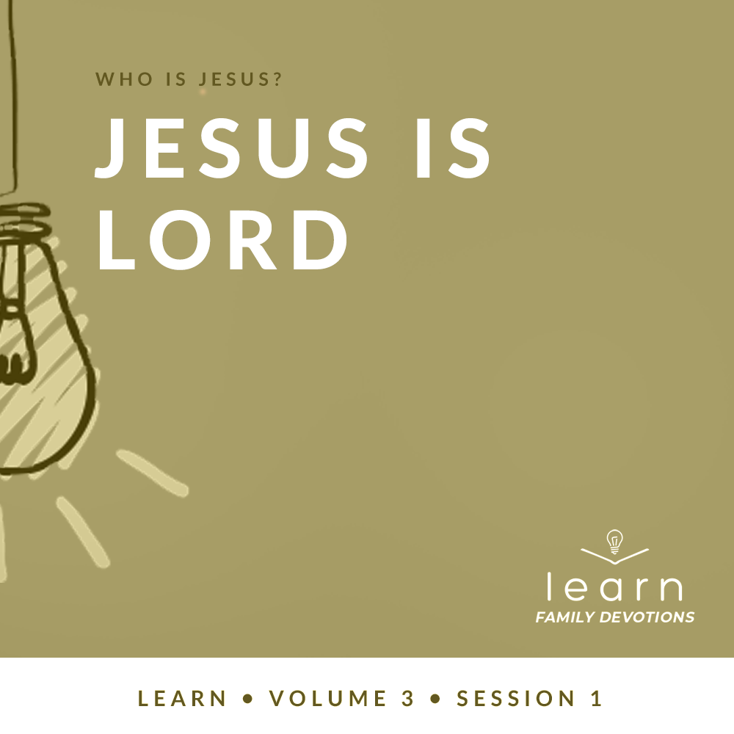

Day 1
Faith Fact
I will follow Jesus.
Faith Verse
John 3:16 (NLT)
“For this is how God loved the world: He gave his one and only Son, so that everyone who believes in him will not perish but have eternal life.”
Question of the Day: Who is Jesus?
Read about It
Read: Matthew 16:13–20
When Jesus came into the world, many people didn’t understand who He was. The Jewish people were waiting for the Messiah. Most Jews thought the Messiah would be someone who would save them from the Roman government.
Jesus did not come in the way they were expecting the Messiah to come. He showed a different kind of power than what the rulers of that day had. The salvation He offered was not the salvation many of the Jewish people were looking for. Yet, as Jesus’ disciples followed Him, God showed them that Jesus is the Messiah, the Son of the Living God. When we follow Jesus, we get to know Him more. He changes us and shows us the life He has for us.
Talk about It
Question 1. Who did Simon Peter say that Jesus was?
Answer 1. Simon Peter said, “You are the Messiah, the Son of the living God.” (Matthew 16:16)
Question 2. Who showed Simon Peter who Jesus was?
Answer 2. God the Father (Matthew 16:17)

Question 3. How was Jesus different from the Jewish people’s expectations for the Messiah?
Answer 3. Answers may vary.

Question 4. How does following Jesus help you learn more about who He is?
Answer 4. Answers will vary.

Question 5. Who do you say that Jesus is?
Answer 5. Answers will vary.

Pray about It
Jesus, thank You for coming to the world to save us. I believe that You are the Messiah, the Son of the Living God. Help me to follow You and to know You more. Amen.

Day 2
Faith Fact
I will follow Jesus.
Faith Verse
John 3:16 (NLT)
“For this is how God loved the world: He gave his one and only Son, so that everyone who believes in him will not perish but have eternal life.”
Question of the Day: What does it mean to follow Jesus?
Read about It
Read: John 13:12–15
Have you ever played a game of Copycat? Someone is chosen to be the leader and everyone else copies everything the leader says and does. If you have a sibling, they may have done this to annoy you, or you may have played copycat to annoy them! However, in these Scripture verses, Jesus said He wanted His followers to copy Him: “I have given you an example to follow. Do as I have done to you.”
Jesus lived a perfect life and showed us exactly how we should live. He led by example and gave us His Word to show us what to do. When we say yes to following Jesus, it doesn’t mean that we’re going to live perfectly. It simply means that, through the power of the Holy Spirit, we are going to do our best to copy everything Jesus did and live our life the way He lived here on earth. When we live the way Jesus did, we are able to show others who He is and the great love that He has for them!
Talk about It
Question 1. What was Jesus showing His disciples an example of?
Answer 1. He washed their feet and showed them how to serve and love others. (John 13:12–15)

Question 2. Did Jesus just use words to tell us how to live?
Answer 2. No, He showed us by His actions how we should live. (John 13:15)

Question 3. What does it mean to follow Jesus?
Answer 3. Answers will vary.

Question 4. Why is it sometimes hard to follow Jesus’ example?
Answer 4. Answers may vary.

Question 5. What is one area of your life that you want to follow Jesus better in?
Answer 5. Answers will vary.
Pray about It
Jesus, thank You for showing us the perfect example of how to live. Help us to follow You in every part of our life. Amen.

Day 3
Faith Fact
I will follow Jesus.
Faith Verse
John 3:16 (NLT)
“For this is how God loved the world: He gave his one and only Son, so that everyone who believes in him will not perish but have eternal life.”
Question of the Day: Why should I follow Jesus?
Read about It
Read: John 8:12
Different religions around the world worship different people and things. Some religions worship things in nature, like trees or the sun. Some religions worship ancestors and people who lived and died long ago. Some people even worship things like money, sports, and entertainment. They walk in spiritual darkness because they worship false gods.
Jesus said He is the Light of the World. Whoever follows Him will never walk in darkness, but will have the light of life. Jesus is the only way to eternal life. When we follow Him and worship Him alone, we walk in the light and truth of who He is. Following anything or anyone other than Jesus leads only to spiritual and eternal darkness.
Talk about It
Question 1. Who did Jesus say does not have to walk in darkness?
Answer 1. Those who follow Him (John 8:12)

Question 2. What did Jesus say you would have if you follow Him?
Answer 2. You will have the light that leads to life. (John 8:12)

Question 3. How is Jesus different from any other religious figure that people follow?
Answer 3. He is the only way to eternal life. Whoever believes in Him can have eternal life. (John 3:16)

Question 4. Why do you think some people worship and follow things other than Jesus?
Answer 4. Answers may vary.

Question 5. Why is following Jesus different from following anyone or anything else?
Answer 5. Answers will vary.
Pray about It
Jesus, thank You for being the Light of the World. I believe that You are the only way to eternal life. Help me to follow and worship You alone. Amen.

Day 4
Faith Fact
I will follow Jesus.
Faith Verse
John 3:16 (NLT)
“For this is how God loved the world: He gave his one and only Son, so that everyone who believes in him will not perish but have eternal life.”
Question of the Day: How can I follow Jesus?
Read about It
Read: Matthew 7:21–23
Who is the most famous celebrity you can think of? Maybe it’s a famous sports player, an actor or actress, or a musician. You may seem to know a lot about the person: their name, what they’re famous for, their favorite food, and what they do in their free time. However, knowing these things doesn’t mean that you know them personally.
Following Jesus isn’t just about knowing His name or things about Him. Following Jesus is about making choices that line up with His Word. It’s about having a personal relationship with Jesus. To do that you spend time with Him and worship Him in all that you do. When you follow Jesus, you come to know Him deeply because He is your personal Friend, your Savior who knows you better than you know yourself!
Talk about It
Question 1. Based on these verses, who will be allowed to enter heaven?
Answer 1. “Only those who actually do the will of my Father in heaven will enter.” (Matthew 7:21)

Question 2. What’s the difference between knowing about a person and actually knowing someone?
Answer 2. Answers will vary.

Question 3. What are some things you have learned about Jesus because you spend time with Him and know Him?
Answer 3. Answers will vary.

Question 4. How is following Jesus different from just knowing about Him?
Answer 4. Answers may vary.

Question 5. How can you know Jesus better and follow Him more closely?
Answer 5. Answers may vary.
Pray about It
Jesus, thank You that I can have a personal friendship with You and not just know about You. As I follow You, help me to draw closer to You and to know You more. Amen.

