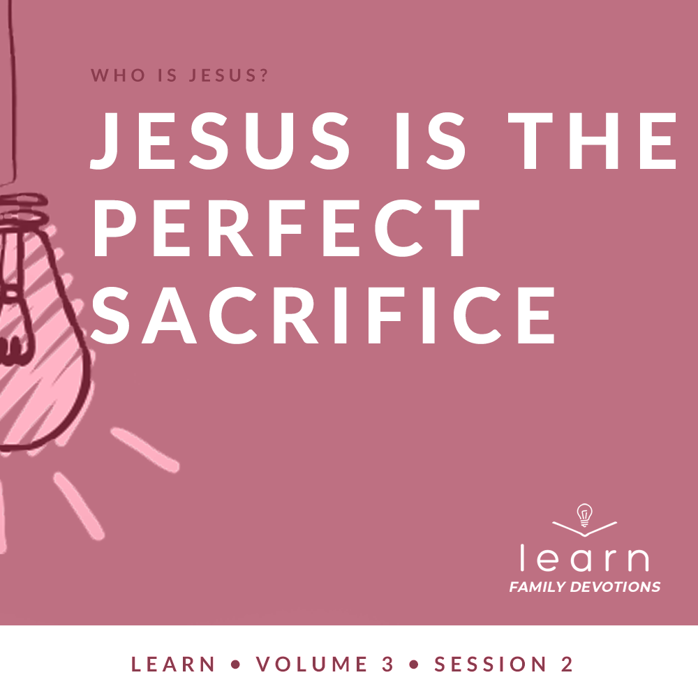

Day 1
Faith Fact
Jesus loves the world.
Faith Verse
John 3:16 (NLT)
“For this is how God loved the world: He gave his one and only Son, so that everyone who believes in him will not perish but have eternal life.”
Question of the Day: Why did Jesus sacrifice His life?
Read about It
Read: John 3:16–17
Think for a moment about the best gift you’ve ever received. Maybe you received a shiny new bike for your birthday. Or, perhaps you received the coolest new video game for Christmas. Or, maybe, someone gave you surprise trip to a place you wanted to go. Who gave you this special gift? It was probably given to you by someone who cares about you and loves you very much.
God loved the world so much that He gave us a special gift. He gave His Son Jesus who willingly sacrificed His own life so we could receive the gift of eternal life. This gift is available to everyone in the world! The Bible says that those who believe in Jesus and live to honor Him will receive the gift of a relationship with God the Father and eternal life with Him. That is, for sure, the best gift you will ever receive!
Talk about It
Question 1. What gift did God give to the world in the Bible verses you just read?
Answer 1. God gave His one and only Son (John 3:16)
Question 2. How can we receive the gift of eternal life?
Answer 2. By believing in Him (John 3:16)

Question 3. Why did God send His Son into the world?
Answer 3. So that the world, through Him, could be saved (John 3:17)

Question 4. How is the gift of God’s Son, Jesus, and the gift of eternal life different from any other gift you’ve ever received?
Answer 4. Answers may vary.

Question 5. What can you do to tell others about this special gift that God has made available to all people?
Answer 5. Answers may vary.
Pray about It
God, thank You for loving us so much that You were willing to give Your Son Jesus. Thank you for making a way for the world to be saved from sin and for giving us the gift of eternal life. Amen.

Day 2
Faith Fact
Jesus loves the world.
Faith Verse
John 3:16 (NLT)
“For this is how God loved the world: He gave his one and only Son, so that everyone who believes in him will not perish but have eternal life.”
Question of the Day: What happened after Jesus died?
Read about It
Read: 1 Corinthians 15:3–8
Can you imagine what it might have been like to see Jesus after He was raised from the dead? Some of the people these verses talk about had seen Jesus on the cross, watched Him die, and had seen His tomb. Yet, just as the Scriptures had promised, three days later He was raised from the dead! Hundreds of people saw Him after He came back to life. What an incredible event to be able to witness! There must have been feelings of shock and surprise, feelings of hope and feelings of joy when people saw that Jesus had defeated death. These people told others about this incredible event whenever they could.
We can experience the same type of hope and joy that the people who saw Jesus experienced. Jesus rose from the dead and was victorious over death, the grave, and sin! Out of love for us, Jesus sacrificed His life so that we could be victorious over sin and have the hope and joy of eternal life with Him forever.
Talk about It
Question 1. How many of Jesus’ followers saw Him after He was raised from the dead?
Answer 1. More than five hundred (1 Corinthians 15:5–6)

Question 2. How does knowing Jesus is victorious over death and sin make you feel?
Answer 2. Answers may vary.

Question 3. In what area do you need Jesus’ help to overcome sin?
Answer 3. Answers may vary.

Question 4. How does knowing Jesus died for you and then returned to life make you feel?
Answer 4. Answers may vary.

Question 5. Who in your life needs to know what Jesus did?
Answer 5. Answers will vary.
Pray about It
Jesus, thank You for sacrificing Your life and defeating death and sin to give us eternal life. Help me to live my life sharing with others about the hope and joy that comes from a relationship with You! Amen.

Day 3
Faith Fact
Jesus loves the world.
Faith Verse
John 3:16 (NLT)
“For this is how God loved the world: He gave his one and only Son, so that everyone who believes in him will not perish but have eternal life.”
Question of the Day: How is living as a Christian like a race?
Read about It
Read: Hebrews 12:1–3
Have you ever seen someone after they’ve run a long race? Typically, they look like they could just collapse at any moment. They have put every bit every bit of energy they have into finishing as high in the standings as they can. Often, they are out of breath, sweating heavily, tired, and hungry.
When Jesus sacrificed His life on the cross, He gave everything He had to do what was required to pay for our sins. He didn’t care what He looked like or what it cost Him. He willingly sacrificed His life for us because He loves us. He knew that because of His sacrifice, we would be able to have a relationship with God and have eternal life with Him in heaven. Knowing that should keep us pressing on to finish the race that God has set before us.
Talk about It
Question 1. Who is the champion of our faith?
Answer 1. Jesus (Hebrews 12:2)

Question 2. What did Jesus have to endure when He was living here on earth?
Answer 2. The cross, hostility from sinful people (Hebrews 12:2–3)

Question 3. What does “run with endurance” mean to you?
Answer 3. Answers will vary.

Question 4. What are some things that slow you down or trip you up in your relationship with God?
Answer 4. Answers will vary.

Question 5. What do you need to do to take off those things and run the way God desires?
Answer 5. Answers will vary.
Pray about It
Jesus, thank You for living a perfect life and being an example for us of how to live. Help me to run the race You’ve set before me with everything in me. Help me to get rid of the things in my life that slow me down and trip me up. Amen.
Day 4
Faith Fact
Jesus loves the world.
Faith Verse
John 3:16 (NLT)
“For this is how God loved the world: He gave his one and only Son, so that everyone who believes in him will not perish but have eternal life.”
Question of the Day: How is Jesus’ sacrifice an example of how we should live?
Read about It
Read: Romans 12:1–2
Something amazing happens when you add Mentos® candy to a bottle of soda. As soon as you drop the candy into the soda, a change happens. Soda begins to shoot out of the bottle. If you put enough Mentos in the bottle, you can make the soda go superhigh.
Something more amazing happens when people accept Jesus as Savior and allow Him to change the way they think and live.
Jesus was willing to give up everything so we could have eternal life with Him. The Bible says that the true way to worship Him is to give Him all of us—to sacrifice our own desires and will to please Him, and follow His desires and His will. When we turn away from the things of the world, give ourself to God, and allow Him to transform our life, we become more like Jesus and learn to walk in the perfect will of God. Then God takes our life and uses it to change those around us.
Talk about It
Question 1. How did Jesus sacrifice himself for us?
Answer 1. He gave His life for us by dying on the cross for our sins.

Question 2. How can we sacrifice ourself for God?
Answer 2. We can be a “living and holy sacrifice” by giving control of our life to God (Romans 12:1)

Question 3. How does God help us live differently from the rest of the world?
Answer 3. When we let God transform us into a new person, He changes the way we think so we can know God’s will for us. (Romans 12:2)

Question 4. When you think of all that God has done for you, how do you want to respond?
Answer 4. Answers will vary.
Question 5. Who in your life needs to know about the change that can happen because Jesus sacrificed himself for us?
Answer 5. Answers will vary.
Pray about It
Jesus, thank You for all that You have done for me by sacrificing Your own life. Help me to live my life as a “living and holy sacrifice” and worship You in all that I do. Amen.

