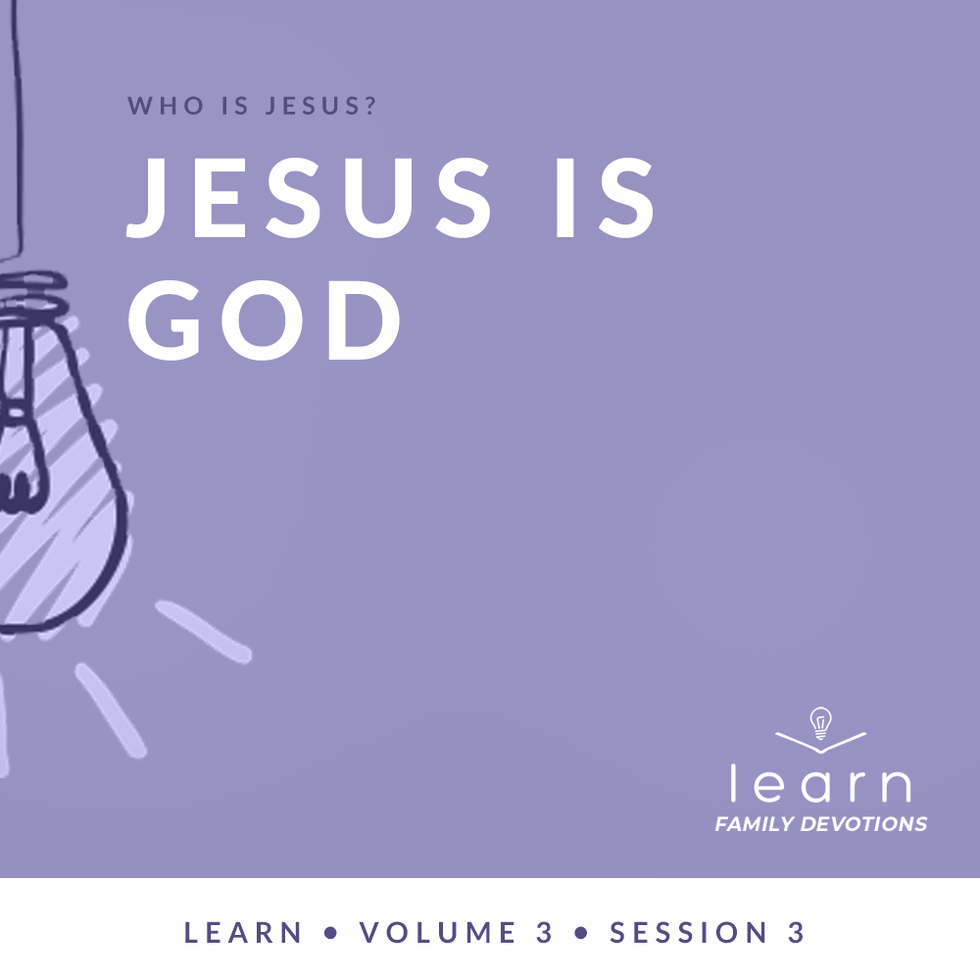

Day 1
Faith Fact
Jesus is alive.
Faith Verse
John 3:16 (NLT)
“For this is how God loved the world: He gave his one and only Son, so that everyone who believes in him will not perish but have eternal life.”
Question of the Day: How did Jesus come to earth?
Read about It
Read: Matthew 1:18–24
What is the most surprising thing that has ever happened to you? Maybe someone gave you a surprise birthday party or jumped around a corner and surprised you when you didn’t know they were there. Surprises can be good or bad. Either way, you will have feelings associated with the surprise.
When Joseph found out Mary was pregnant, we can only imagine how he must have felt. This was probably the biggest surprise of his life. The woman he planned to marry was carrying the Son of God—Jesus, the promised Messiah, the One who would save His people from their sins. Jesus willingly left heaven and came to earth as a baby for one purpose: to save us. He came to earth, full of love for us, knowing that He would end up giving His life to cover the penalty of our sins. But, He also knew that three days later He would rise again. Jesus is alive right now and is actively working in our life when we trust in Him.

Talk about It
Question 1. Whom did Joseph plan to marry?
Answer 1. Mary (Matthew 1:18)

Question 2. Who appeared to Joseph and told him that Jesus was going to be born?
Answer 2. An angel of the Lord (Matthew 1:20)

Question 3. Why did the angel tell Joseph to name the baby, Jesus?
Answer 3. He was to name Him Jesus because “He will save his people from their sins.” (Matthew 1:21)

Question 4. How does knowing that Jesus came to earth to save people from their sins make you feel?
Answer 4. Answers will vary.

Question 5. How does knowing that Jesus is alive change the way you live?
Answer 5. Answers will vary.
Pray about It
Jesus, thank You for having a plan to come to earth to save us from our sins. Thank You for being willing to leave heaven, die on the cross, and rise to life again. Amen.

Day 2
Faith Fact
Jesus is alive.
Faith Verse
John 3:16 (NLT)
“For this is how God loved the world: He gave his one and only Son, so that everyone who believes in him will not perish but have eternal life.”
Question of the Day: Why did Jesus take our place?
Read about It
Read: 1 Peter 2:21–25
In baseball, coaches use a pinch hitter as a substitute for another player, usually a weaker hitter, who is due up to bat. Jesus covered our weaknesses by becoming a substitute for us.
Jesus is the only person who never sinned. Because of this, He is the only one who could be our substitute by taking the punishment for our sins. Jesus is fully God and fully human. His death and resurrection show His power to heal us spiritually, emotionally, mentally, and physically. When we trust Jesus and follow His ways, He will lead us and guide us to the full life He has planned for us. We will see His power in our life.
Talk about It
Question 1. Why was Jesus the only one who could take our place?
Answer 1. He is the only person who ever lived a perfect life without sin.

Question 2. How did Jesus pay the punishment for our sins?
Answer 2. He died on the cross. (1 Peter 2:24)

Question 3. Why can we be healed in every part of our life?
Answer 3. Jesus’ death and resurrection proves His power to heal and make every part of our life whole. “By his wounds, you are healed.” (1 Peter 2:24).

Question 4. How does knowing that Jesus took your place make you feel?
Answer 4. Answers will vary.

Question 5. In what part of your life do you need Jesus to show His power in your weakness?
Answer 5. Answers will vary.
Pray about It
Jesus, thank You for coming to take my place and taking the punishment for my sins. Thank You for being more powerful than any weakness I face. Help me to trust You and allow You to show Your power in my life. Amen.

Day 3
Faith Fact
Jesus is alive.
Faith Verse
John 3:16 (NLT)
“For this is how God loved the world: He gave his one and only Son, so that everyone who believes in him will not perish but have eternal life.”
Question of the Day: Where did Jesus’ power come from?
Read about It
Read: John 1:1–5, 14
It’s hard for us to imagine before “the beginning,” because for us, everything has a starting point. But, the Bible says that “in the beginning the Word already existed. The Word was with God, and the Word was God.” The Bible is referring to Jesus before He came to earth, and it calls Him “the Word.” Jesus is God and was with God the Father even before the beginning. He was never created. He simply always has been. Doesn’t that just blow your mind? Through Jesus’ power, He gave life to everything that was created. And when He came to earth in human form, His life brought light and life to all who believe in Him.
When you look in a mirror, you see a reflection of yourself. It’s the same person, but it’s as if two different people are standing there. The mirror reveals to us what we look like and reflects who we are. Jesus, the Word, reveals and reflects who God is. Jesus is fully God, but came to earth and experienced everything humans face. But, He lived without sinning. Then, after He gave His life to pay for our sin, He showed the power of God by raising from the dead. He did all of this so we could have a relationship with God the Father and experience for ourself the life that Jesus brings.
Talk about It
Question 1. Who created Jesus?
Answer 1. No one. In the beginning the Word (Jesus) already existed, He was with God and was God. He existed in the beginning with God. (John 1:1–2)

Question 2. What did the Word (Jesus) give life to?
Answer 2. The Word gave life to everything that was created. (John 1:3)

Question 3. What did His life bring when He came to earth?
Answer 3. His life brought light to everyone, light that shines in the darkness. (John 1:4–5)

Question 4. How do these verses show the power that Jesus, the living God, has?
Answer 4. Answers may vary.

Question 5. What situation do you need Jesus to bring life and light to?
Answer 5. Answers will vary.
Pray about It
Jesus, when I think about Your power and the life You bring, it blows my mind! There is no one who compares to You! Thank You for making it possible for me to have a relationship with God the Father and for bringing life and light to my life. Amen.

Day 4
Faith Fact
Jesus is alive.
Faith Verse
John 3:16 (NLT)
“For this is how God loved the world: He gave his one and only Son, so that everyone who believes in him will not perish but have eternal life.”
Question of the Day: What does Jesus have power over?
Read about It
Read: Hebrews 1:3
Casting is an art form that makes a duplicate sculpture of something. An artist will mix a special powder with water and place it around a person’s hands until the mold is set. Their hands are removed from the mold. Then a mixture of plaster of Paris is poured into the mold and given several hours to dry. Once dried, the mold is removed to reveal an exact replica of the person’s hands. The cast, down to the very tiny details, is the exact imprint of the person’s hands.
The Scripture we read today talks about how Jesus expresses the very character of God. He allowed people to see the radiance of God’s glory. All the power of God, Jesus has because Jesus is God. After Jesus rose from the dead, He ascended to heaven and is now seated “at the right hand” of the Father. Jesus is alive and because He holds all power, He wants us to trust Him with our life. Jesus, the living God, has power over everything we face. Because He loves us, He is willing to work and move for us!
Talk about It
Question 1. Whose character and glory does Jesus show?
Answer 1. God (Hebrews 1:3)

Question 2. Where is Jesus now?
Answer 2. Jesus is seated at the right hand of God (Hebrews 1:3)

Question 3. What words would you use to describe Jesus’ power?
Answer 3. Answers will vary.

Question 4. How does knowing that Jesus has power over everything make you feel?
Answer 4. Answers will vary.

Question 5. Why do some people trust their own ways instead of trusting Jesus, who is alive and has power over everything?
Answer 5. Answers will vary.
Pray about It
Jesus, I believe that You are God and are all-powerful. Help me to trust You, no matter what situations I may face. Amen.

