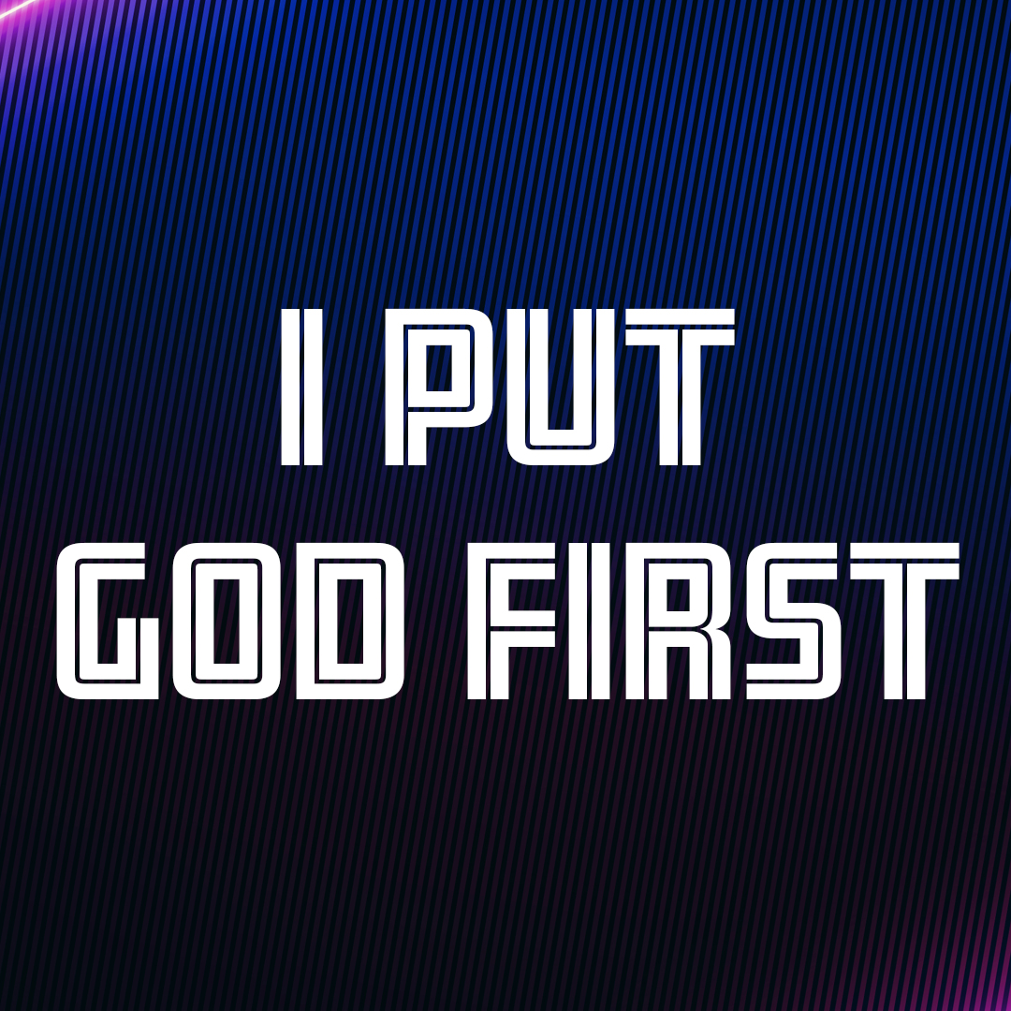

Day 1
Faith Fact
I put God first.
Faith Verse
Matthew 6:33 (NLT)
“Seek the Kingdom of God above all else, and live righteously, and he will give you everything you need.”
Question of the Day: How can I put God first?

Read about It
Read: Deuteronomy 6:4–7
Professional athletes work hard to be 100 percent committed to their sport. They are careful to get up in the morning to exercise their body. They take great care in what they eat and drink, making sure to eat enough protein, vitamins, and minerals. They spend their days practicing drills, going over plays, and working to get better. If they fail to practice or do not train their body properly, they will likely not play well and could have to find a new profession.
An athlete’s level of commitment to the sport is similar to the level of commitment to God that the Bible says Christians should have. How we talk and what we do should always reflect a wholehearted commitment to God.
As you live for Him in every part of your life and love Him with all your heart, soul, and strength, He will help you and make sure that you have everything you need to live for Him!

Talk about It
Question 1. How should we love God?
Answer 1. We should love God with all our heart, all our soul, and all our strength. (Deuteronomy 6:5)

Question 2. How should you commit yourself to God’s commands?
Answer 2. “You must commit yourselves wholeheartedly.” (Deuteronomy 6:6)

Question 3. How often should we talk about what God expects of us?
Answer 3. “When you are at home and when you are on the road, when you are going to bed and when you are getting up.” (Deuteronomy 6:7)

Question 4. What is one thing you can do to help you live wholeheartedly for God?
Answer 4. Answers will vary.

Question 5. What is something in your life that may be keeping you from living wholeheartedly for God?
Answer 5. Answers will vary.

Pray about It
Father God, I believe that You alone are God. I want to love You with all my heart, all my soul, and all my strength. Help me to be fully committed to You in every part of my life. Amen.

Day 2
Faith Fact
I put God first.
Faith Verse
Matthew 6:33 (NLT)
“Seek the Kingdom of God above all else, and live righteously, and he will give you everything you need.”
Question of the Day: Why should I put God first?

Read about It
Read: Matthew 13:44–46
The verses in today’s passage are two of Jesus’ parables that compare the kingdom of heaven, or God’s Kingdom, to things here on earth. The treasure hidden in a field and the choice pearl were both things of great value. They were so valuable that everything else was sold in order to gain them.
This is how it is with being a part of God’s family. Being connected with Jesus is more valuable than anything we have here on earth. Our life on earth is temporary. It won’t last forever. Yet, sometimes we live our life as we want, instead of putting God first. When we live our life for God, we are willing to give up anything we need to give up to gain the most valuable treasure of all, eternal life and a relationship with Him forever.
Talk about It
Question 1. What did the man do when he found the treasure in the field?
Answer 1. He hid it again and sold everything he owned to get enough money to buy the field. (Matthew 13:44)

Question 2. What did the merchant do when he discovered a pearl of great value?
Answer 2. He sold everything he owned and bought it. (Matthew 13:46)

Question 3. Why are eternal life and our relationship with God more important than anything else here on earth?
Answer 3. Our relationship with God and eternal life will last forever. Most things in this world will not last forever.

Question 4. How is my relationship with God the most valuable treasure of all?
Answer 4. Answers may vary.

Question 5. What are some things in my life that I need to get rid of to ensure that I can have that treasure, a relationship with God?
Answer 5. Answers may vary.
Pray about It
God, thank You for making it possible for me to have a relationship with You. Help me to value that relationship more than anything else here on earth. Amen.

Day 3
Faith Fact
I put God first.
Faith Verse
Matthew 6:33 (NLT)
“Seek the Kingdom of God above all else, and live righteously, and he will give you everything you need.”
Question of the Day: What is most important to me?
Read about It
Read: Matthew 6:19–21
Have you ever been in an attic filled with boxes and trunks? Many times these boxes and trunks are filled with things people valued at one time. They placed items they thought were treasures inside the trunks. But, after years in the attic, dirt, dust, rust, and moths have damaged or destroyed things that were once important.
The Bible clearly tells us not to store treasures on earth where things can be destroyed, stolen, broken, or discarded. But, rather, our treasure should be in heaven. Jesus wasn’t saying we couldn’t have nice things, but that we need to make sure that what we most care about and put first in our life is God. When we treasure our relationship with God more than anything else, He becomes the desire of our heart, and what He has for us is better than any treasure we could have here on earth.
Talk about It
Question 1. What can happen to your earthly treasures?
Answer 1. They can rust. They can be destroyed, and they can be stolen. (Matthew 6:19)

Question 2. What can happen to your treasures in heaven?
Answer 2. They cannot rust, be destroyed, or stolen (Matthew 6:20)

Question 3. How is the location of your treasure related to your heart’s desires?
Answer 3. “Wherever your treasure is, there the desires of your heart will also be.” (Matthew 6:21)

Question 4. When have you chosen to put God first?
Answer 4. Answers will vary.

Question 5. How is putting God first better than putting any earthly treasures or possessions first?
Answer 5. Answers may vary.
Pray about It
God, You are more important to us than anything else in this world. May every word we say, every thought we think, and every action we take show that You are number one in our life. Amen.

Day 4
Faith Fact
I put God first.
Faith Verse
Matthew 6:33 (NLT)
“Seek the Kingdom of God above all else, and live righteously, and he will give you everything you need.”
Question of the Day: What is keeping me from putting God first?
Read about It
Read: 1 John 2:15–17
Have you ever seen someone place a cookie on a table in front of a child, and then say to the child, “I need to step out of the room for a minute. If that one cookie is still there when I come back, I will give you a second cookie.”
It’s interesting to watch what the child does. Sometimes the child gobbles up the cookie. In that case, the child may enjoy the cookie but misses out on getting a second. But, when you see a child refuse to eat the cookie in order to get a second cookie, it just makes you want to jump up and cheer because they got something so much better!
Sometimes it can be difficult to choose the things of God over our immediate desires. When we have friends or family who do things that look like fun, but go against God, it can be difficult to say no to that temptation. However, when we honor God in the choices we make and choose to put Him first, we receive something far better than the short-term pleasure of a sin that leads to destruction. We must be willing to sacrifice the things in our life that distract us from God’s very best for us, because “anyone who does what pleases God will live forever” (verse 17).
Talk about It
Question 1. In these verses, what does the Bible warn us not to love?
Answer 1. “Do not love this world nor the things it offers you.” (1 John 2:15)

Question 2. What does the Bible tell us about the things of the world?
Answer 2. “This world is fading away, along with everything that people crave.” (1 John 2:17)

Question 3. Why is what God wants for us better than what we may want for ourself?
Answer 3. Answers may vary.

Question 4. How does putting God first help us to receive God’s very best for us?
Answer 4. Answers will vary.

Question 5. What are you allowing in your life that is distracting you from putting God first?
Answer 5. Answers will vary.
Pray about It
God, thank You that what You desire for me is so much better than what I could ever imagine. Help me to always choose You and Your ways. I want to put You first in every part of my life. Amen.

