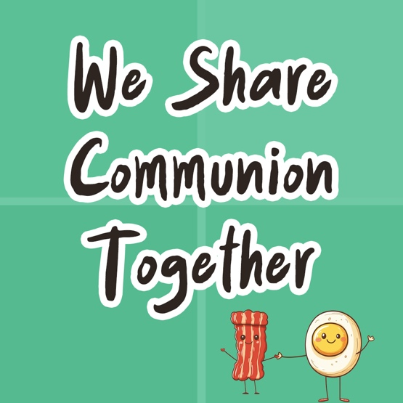

Day 1
Faith Fact
We share together.

Faith Verse
Matthew 18:20 (NLT)
“For where two or three gather together as my followers, I am there among them.”

Question of the Day: What is your favorite memory?
Read about It
Read: Matthew 26:17–19, 26–30
Jesus knew His death was quickly approaching. One of the last things Jesus did was meet with His disciples and share a very special meal with them. While they were eating, Jesus explained to them what each part meant and its significance. We remember this night through something we call Communion. When we take Communion, we remember what Jesus said and how He gave His life on the Cross.
It is powerful when a group gathers and stops what they are doing to reflect on what Jesus has done for them. His body was broken and His blood was shed so that every person could receive eternal forgiveness. Jesus modeled what Communion would look like with the disciples and how it can be shared together with all believers today. Communion reminds us of what Jesus has done for us, and it looks forward to His return.

Talk about It
Question 1. What was the name of the festival that Jesus and the disciples were celebrating?
Answer 1. The Festival of Unleavened Bread and Passover (Matthew 26:17)

Question 2. What did the bread symbolize?
Answer 2. Jesus’ body which was broken for us (Matthew 26:26)

Question 3. What did the cup symbolize?
Answer 3. Jesus’ blood which was shed for us (Matthew 26:27)

Question 4. Why is Communion important?
Answer 4. It reminds us of what Jesus has done for us and looks forward to His return.
Pray about It
Dear Jesus, thank You for giving us the pattern of Communion to remind us of what You have done. Thank You that Communion also looks ahead to Your return. Jesus, I love You and thank You for dying on the Cross so that my sins could be forgiven. Thank You for loving me. Amen.

Day 2
Faith Fact
We share together.

Faith Verse
Matthew 18:20 (NLT)
“For where two or three gather together as my followers, I am there among them.”

Question of the Day: What foods spark memories of people or events?
Read about It
Read: 1 Corinthians 11:23–26
Has a smell ever made you remember something special? Maybe the smell of cookies fresh from the oven makes you think about Christmas time. Or maybe you tasted something, and it made you think of someone? Grilled hamburgers make you think about your grandpa. Sometimes smells and tastes have a way of doing that. They can remind us of things from our past.
When we take Communion, we stop and think about what Jesus did on the Cross for all of us and how much He loves us. Jesus died on the Cross so that we can be forgiven of our sins. Every time we take Communion, we have a chance to remember how much He loves us. We should also remember to tell others about Him so that they can experience His love and forgiveness too.
Talk about It
Question 1. What are some emotions you may feel when you take Communion?
Answer 1. Answers may vary.

Question 2. How does knowing Jesus died for you change your life?
Answer 2. Answers will vary.

Question 3. How would you explain the significance of Communion bread to someone?
Answer 3. It represents Jesus’ broken body. (1 Corinthians 11:24)

Question 4. How would you explain the significance of the Communion juice to someone?
Answer 4. It represents Jesus’ blood. (1 Corinthians 11:25)

Question 5. How does taking Communion help us remember Jesus’ death?
Answer 5. Answers may vary.
Pray about It
Dear Jesus, thank You for Your promise of salvation and for dying on the Cross for my sins. I am so thankful for the love and grace You showed to each one of us. I love You. Amen.

Day 3
Faith Fact
We share together.

Faith Verse
Matthew 18:20 (NLT)
“For where two or three gather together as my followers, I am there among them.”

Question of the Day: When do you spend time with Jesus?
Read about It
Read: John 6:43–59
Spending time with Jesus is important. When we spend time reading the Bible and in prayer, we grow to know more and more that Jesus is the Source of everything we need. We see in these verses that He talked about being the Bread of Life. Only through Jesus can we experience eternal salvation, grace, and forgiveness of our sins.
Jesus came to earth to die on the Cross for our sins. We can’t earn forgiveness or earn God’s love. He freely gave it to us through Jesus. When we ask Jesus to come into our life and forgive our sins, we experience that grace and love. We experience the gift of new life through Christ Jesus, and it is one of the greatest things we will ever experience. Jesus is the Way, the Truth, and the Life and only through Him can we be saved.
Talk about It
Question 1. What do you think Jesus meant when He called himself “the bread of life”?
Answer 1. Answers will vary.

Question 2. What did Jesus say about anyone who believes?
Answer 2. They have eternal life. (John 6:47)

Question 3. How do you think you would have reacted to these words: “Unless you eat the flesh of the Son of Man and drink his blood, you cannot have eternal life within you”?
Answer 3. Answers may vary.

Question 4. What is God saying to you today from this devotion?
Answer 4. Answers may vary.
Pray about It
Dear God, thank You that You are my Source and that everything I need comes from You. Thank You for loving me enough to send Jesus to die for me. Help me not take what Jesus did for granted. I love You, God. I choose every day to follow You and to put You first in my life. Amen.
Day 4
Faith Fact
We share together.

Faith Verse
Matthew 18:20 (NLT)
“For where two or three gather together as my followers, I am there among them.”

Question of the Day: When have you received healing?
Read about It
Read: Isaiah 53:5
This text written by Isaiah was written hundreds of years before what Jesus did for us. What He did is beyond incredible. Jesus never did anything wrong. Yet because of His love for us, He took upon himself the sins of the world. He was made fun of, laughed at, beaten, broken, and died on the Cross so that we could experience the gift of grace and forgiveness from sin.
But He didn’t stay dead. Three days later, He defeated death and rose from the grave. He conquered not only sin, but also sickness and pain, making physical healing part of the Atonement. Atonement is a big word that means Jesus’ sacrificial death could make our relationship with God complete and good. Jesus rose from the dead and when He rose He was victorious over death and sin.
Because of what Jesus did on the Cross and because He rose again and defeated sin, death, and sickness, we can experience eternal life through Him. We can experience not only forgiveness from sin, but also healing. It’s amazing to think of what Jesus did for each one of us.
Talk about It
Question 1. How does knowing Isaiah wrote this text hundreds of years before Jesus was crucified impact your faith?
Answer 1. Answers will vary.

Question 2. How would you define the word atonement?
Answer 2. Jesus’ sacrificial death made our relationship with God complete and good.

Question 3. How does knowing what Jesus suffered make you feel?
Answer 3. Answers will vary.

Question 4. How did Jesus suffer so people could be healed?
Answer 4. He was whipped and beaten. (Isaiah 53:5)
Question 5. When have you seen God heal someone?
Answer 5. Answers will vary.
Pray about It
Dear Jesus, thank You for suffering and dying on the Cross for my sins so that I could have healing and peace. Please lead and guide me each and every day, and help me tell other people about Your love for them. Amen.

